Version History

|  |  |
| --- | --- |
| 1.0 | Added mappings for Prod-Landing template |
|  |  |
|  |  |
|  |  |

English Page Path: /content/en/us/solutions/enterprise-networks/index

­­­­­­­­­­­­­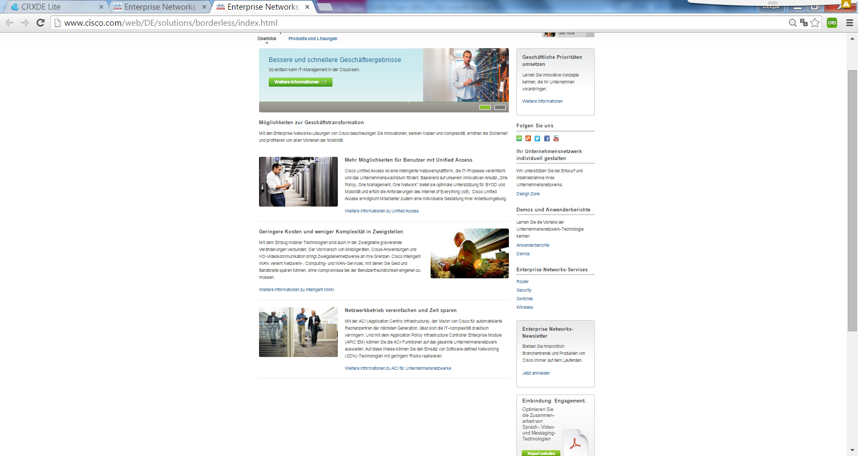

6

5

15

14

13

10

12

11

9

8

4

7

2

3

1

13

|  |  |  |  |
| --- | --- | --- | --- |
| 1 | /content/<locale>/solutions/<product-category>/index/jcr:content/content_parsys/overview*/layout-overview*/gd12v2*/gd12v2-left*/hero_large*/heropanel*/title |  | div.c50-pilot  getElementByTag(“h2”) |
| 2 | /content/<locale>/solutions/<product-category>/index/jcr:content/content_parsys/overview*/layout-overview*/gd12v2*/gd12v2-left*/hero_large*/heropanel*/ description |  | div.c50-pilot.p |
| 3 | /content/<locale>/solutions/<product-category>/index/jcr:content/content_parsys/overview*/layout-overview*/gd12v2*/gd12v2-left*/hero_large*/heropanel*/ linktext  /content/<locale>/solutions/<product-category>/index/jcr:content/content_parsys/overview*/layout-overview*/gd12v2*/gd12v2-left*/hero_large*/heropanel*/ linkurl |  | div.c50-pilot  div.cta-link  getElementByTag(“b”)  div.cta-link.  getElementByTag(“a.href”) |
| 4 | /content/<locale>/solutions/<product-category>/index/jcr:content/content_parsys/overview*/layout-overview*/gd12v2*/gd12v2-left*/text/text |  | div.c00-pilot  getElementByTag(“h2”)  getElementByTag(“p”) |
| 5 | /content/<locale>/solutions/<product-category>/index/jcr:content/content_parsys/overview*/layout-overview*/gd12v2*/gd12v2-left*/spotlight_large_v2*/title |  | div.c11-pilot  getElementByTag(“h2”) |
| 6 | /content/<locale>/solutions/<product-category>/index/jcr:content/content_parsys/overview*/layout-overview*/gd12v2*/gd12v2-left*/spotlight_large_v2*/ description |  | div.c11-pilot  getElementByTag(“p”) |
| 7 | /content/<locale>/solutions/<product-category>/index/jcr:content/content_parsys/overview*/layout-overview*/gd12v2*/gd12v2-left*/spotlight_large_v2*/ linktext  /content/<locale>/solutions/<product-category>/index/jcr:content/content_parsys/overview*/layout-overview*/gd12v2*/gd12v2-left*/spotlight_large_v2*/ cta/url |  | div.c11-pilot  getElementByTag(“a”)  div.c11-pilot  getElementByTag(“a.href”) |
| 8 | /content/<locale>/solutions/<product-category>/index/jcr:content/content_parsys/overview*/layout-overview*/gd12v2*/gd12v2-right*/tile_bordered*/title |  | div.c23-pilot  getElementByTag(“h2”) |
| 9 | /content/<locale>/solutions/<product-category>/index/jcr:content/content_parsys/overview*/layout-overview*/gd12v2*/gd12v2-right*/tile_bordered*/ description |  | div.c23-pilot  getElementByTag(“p”) |
| 10 | /content/<locale>/solutions/<product-category>/index/jcr:content/content_parsys/overview*/layout-overview*/gd12v2*/gd12v2-right*/tile_bordered*/ linktext  /content/<locale>/solutions/<product-category>/index/jcr:content/content_parsys/overview*/layout-overview*/gd12v2*/gd12v2-right*/tile_bordered*/ linkurl |  | div.c23-pilot  getElementByTag(“a”)  div.c23-pilot  getElementByTag(“a.href”) |
| 11 | /content/<locale>/solutions/<product-category>/index/jcr:content/content_parsys/overview*/layout-overview*/gd12v2*/gd12v2-right*/followus/title |  | div.s14-pilot  getElementByTag(“h2”) |
| 12 | /content/<locale>/solutions/<product-category>/index/jcr:content/content_parsys/overview*/layout-overview*/gd12v2*/gd12v2-right*/followus/links |  | div.s14-pilot  getElementByTag(“a.href”) |
| 13 | /content/<locale>/solutions/<product-category>/index/jcr:content/content_parsys/overview*/layout-overview*/gd12v2*/gd12v2-right*/list*/title |  | div.n13-pilot  getElementByTag(“h2”) |
| 14 | /content/<locale>/solutions/<product-category>/index/jcr:content/content_parsys/overview*/layout-overview*/gd12v2*/gd12v2-right*/list*/intro/paragraph_rte |  | div.n13-pilot  getElementByTag(“p”) |
| 15 | /content/<locale>/solutions/<product-category>/index/jcr:content/content_parsys/overview*/layout-overview*/gd12v2*/gd12v2-right*/list*/element_list*/listitems |  | div.n13-pilot  getElementByTag(“li”) |